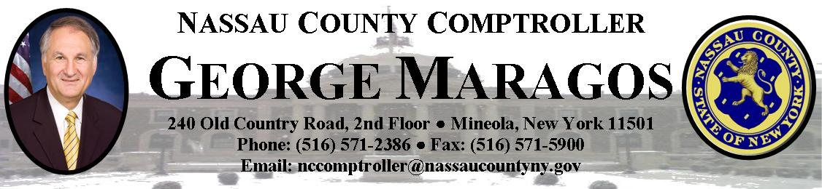

PRESS RELEASE

Contact: Jostyn Hernandez 516-315-8713 January 7, 2014

Maragos: $14M Went Uncollected at Nassau Community College Yet Tuition was Increased

Mineola, NY- Nassau County Comptroller George Maragos released his audit of the financial condition of Nassau County’s Community College and found numerous financial and operational inefficiencies. The major findings included inadequate billing and collection practices that resulted in $14 million being uncollected from 2006- August 2011 while reserves were drawn down to pay for operations and tuition was increased in 2013. Significant improvements have been instituted since the audit, yet numerous additional actions remain to be implemented including reducing staffing ratios, reducing administrative expenses, and proactive tuition payment collection, in order to achieve efficiencies comparable with other community colleges.

“The numerous operational and financial issues uncovered during the audit at the Nassau Community College persisted for too long and if allowed to persist could threaten the mission of the college and cause significant tuition increases in the future,” Comptroller Maragos said. “We are pleased that the Administration has already made substantial changes to improve the financial controls and operating efficiencies. We urge the College Administration to implement all other recommendations including strengthening the management team, reducing administrative expense and bringing student faculty ratios in line with comparable Community Colleges in order to minimize future tuition increases.”

The College reported a net loss in the three years covered by the audit (2010, 2011 and 2012) and has dipped into its reserves for four out of the last five budgets. Its reserves have been depleted to dangerously low levels of less than $10 million.

The major findings include;

- Inadequate billing and collection practices resulted in past due tuition and fees of $14 million dating back to the 2006/2007 academic year. The College’s written guidelines for sending past due letters to students while they were enrolled at the College were not adhered to. The College processed applications in 2010 and 2011 for 5,849 students without receiving the related application fees of $237,000. Although many of these practices have been improved, significant change is still necessary to ensure that every student is treated fairly and the college minimizes uncollected tuition.
- Employee time and leave was not always properly documented, tracked and approved in accordance with labor contracts and college policy for 28 of the 43 employees selected for testing.
- Staffing Levels, Administrative Expenses and Total Operating Costs were out of line with comparable regional colleges.
- The College’s staffing levels for the 2010/2011 school year were 38% higher than the staffing levels at Suffolk Community College with similar student populations.
- The College’s administrative and general expenses for the fiscal year ending August 31, 2011 were the highest when compared to the other three colleges. The College’s total was $56 million, followed by Suffolk at $52 million, Monroe at $41 million and Westchester at $27 million with similar student populations.
- Budgeted operating costs for the 2011/2012 school year were $1,302 more per student at NCC than at Suffolk Community College.

Comptroller Maragos added, “the proposed changes required at the College are significant. The first step is for a permanent president to be installed, with the authority and stature to implement the organizational and financial improvements necessary. Dr. Saunders indicated that he recognizes the issues raised in our audit and that the College has, for several years now, been taking actions that are consistent with many of our recommendations.”

“We agree with many of the Comptroller’s observations and recommendations. We would note that through specific and sustained actions that have already been taken by the College, $4.3 million, or more than 30%, of the previously uncollected tuition and fees have been recovered,” stated Dr. Kenneth Saunders. “I welcome the Comptroller’s and the College Board of Trustees’ support in implementing the structural management changes to improve the College’s operating efficiencies consistent with NCC’s mission of providing an affordable, high quality education to the students attending NCC.”

The full version of our report is available on the Comptroller’s website.

Connect with Nassau County Comptroller Maragos Online:
http://www.nassaucountyny.gov/agencies/Comptroller/index.html

 facebook.com/NCComptroller
 twitter.com/NCComptroller
 youtube.com/NCComptroller

