ATTENTION NCCFT MEMBERS
Personal Care and Household Product Drive
May 18, 2010– NCCFT Luncheon
Please bring items or make a $1.00 Donation
From now until May 18 faculty may drop off items at the NCCFT Office - F3293 or Jean Miller’s Office M228
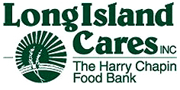
Long Island Cares, Inc. is dedicated to helping our neighbors receive nutritious meals, raise healthy families and enjoy the basic essentials of life. These essentials build confidence and help individuals grow into strong, hardworking citizens within the community.
Below are some suggestions:
Shampoo/Conditioner Deodorant Razor/Razor Blades Combs & Brushes Tooth Brushes/Paste Mouth Wash Feminine Hygiene Items Lotion and Cream Toilet Paper Adult Diapers Under Garments Paper Napkins/Towels Plastic Plates/Bowls Utensils and Cups Can Openers
Laundry Detergent Household Cleaning Products



